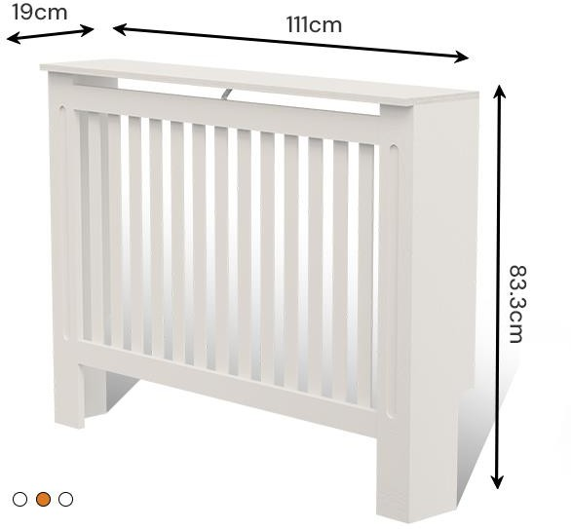
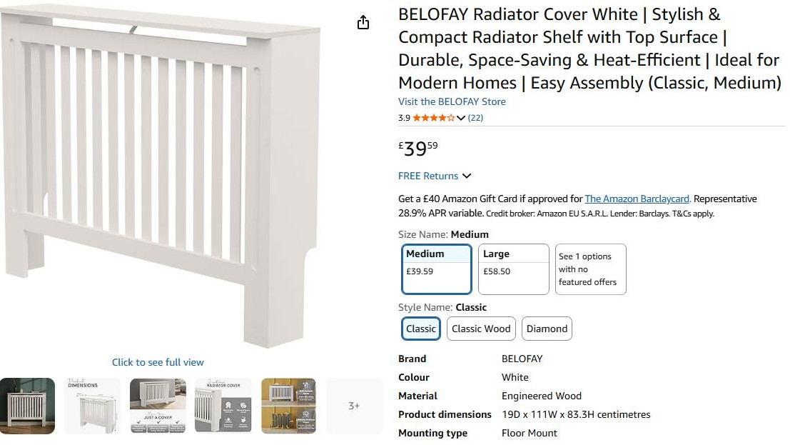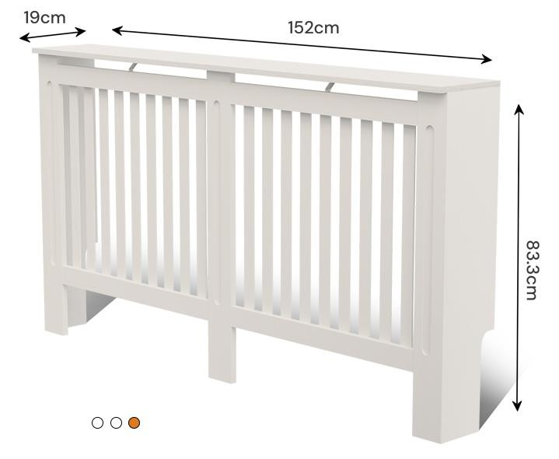
5pcs x BELOFAY Radiator Cover Compact Radiator Shelf 19Dx111Wx83.3H– Medium……Selling on amazon for £39.59
106pcs x BELOFAY Radiator Cover Compact Radiator Shelf 19Dx152Wx83.3H – Large……Selling on amazon for £58.50

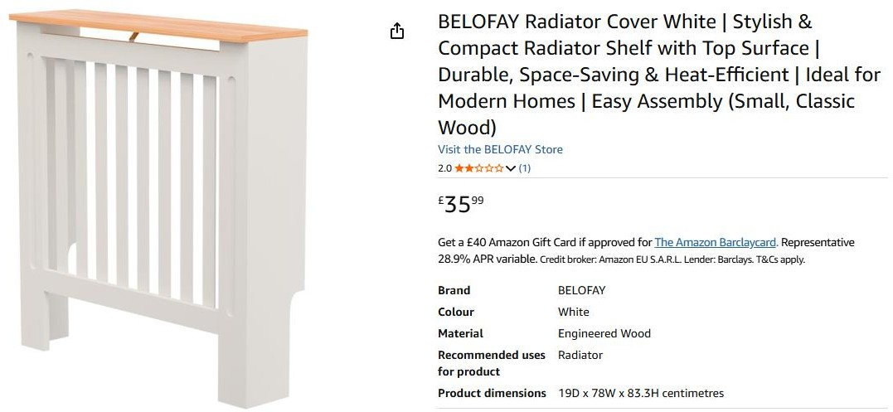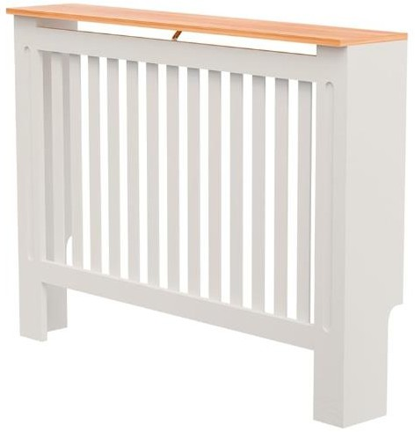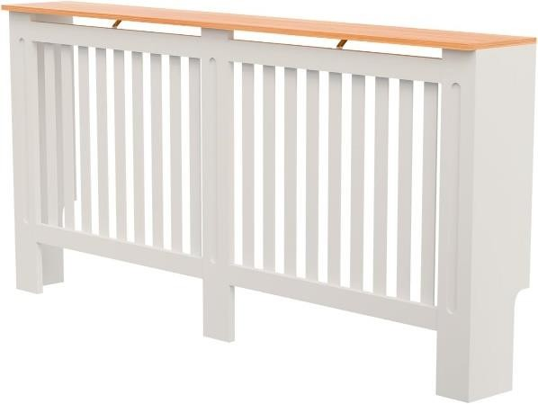

39pcs x BELOFAY Radiator Cover White Classic Wood 19Dx78Wx83.3cm – Small………Selling on amazon for £35.99
320pcs x BELOFAY Radiator Cover White Classic Wood 19Dx111Wx83.3H– Medium………Selling on amazon for £43.19
100pcs x BELOFAY Radiator Cover White Classic Wood 19Dx152Wx83.3H – Large………Selling on amazon for £63.50

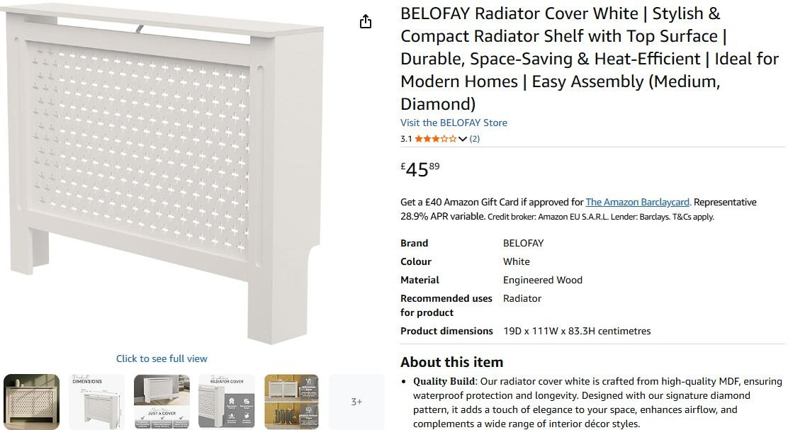
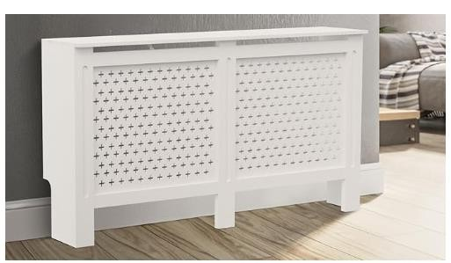
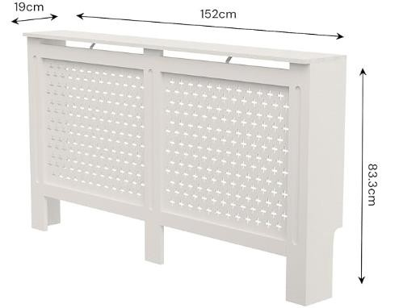

106pcs x BELOFAY Radiator Cover White Diamond 19Dx111Wx83.3H– Medium……….Selling on amazon for £45.8
77pcs x BELOFAY Radiator Cover White Diamond 19Dx111Wx83.3H– Large……….Selling on amazon for £70.50

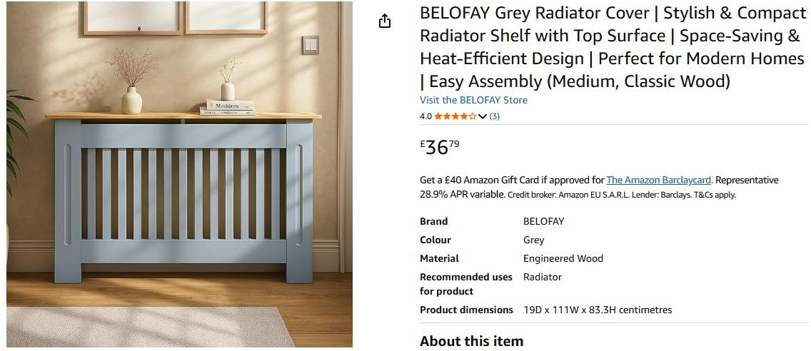

36pcs x BELOFAY Grey Radiator Cover 19Dx111Wx83.3H– Medium………Selling on amazon for £36.79

